# CS 340 README

## About the Project/The Rescued Dog to Rescue Dogs Project

The purpose of our project is to consolidate data from multiple different animal shelters in Austin, TX into an open-source database. Our database will be accessible through a web portal which will allow us to view available animals grouped by specific traits that make them likely candidates for search and rescue work.

## Motivation

Our project exists because there are many dogs in animal shelters that would be great candidates for rescue dog training. Currently there is no easy way to search all the data and find these dogs as individual shelters maintain their own data bases. Our client Grazioso Salvare wishes to consolidate this data and provide visual tools that make it possible to easily identify dogs that would be good for different types of rescue training including water, mountain, and wilderness. This project will help get animals out of shelters and give them better lives and meaningful work. Doing this will help solve the problems of overcrowding in animal shelters and finding dogs for search and rescue work.

## Getting Started

To get started with a new build of this project you would need to do a few things. First you must install MongoDB, Python, and the PyMongo Library. Once this is complete you will need to start an instance of MongoDB and import all your current data into the database as seen below.

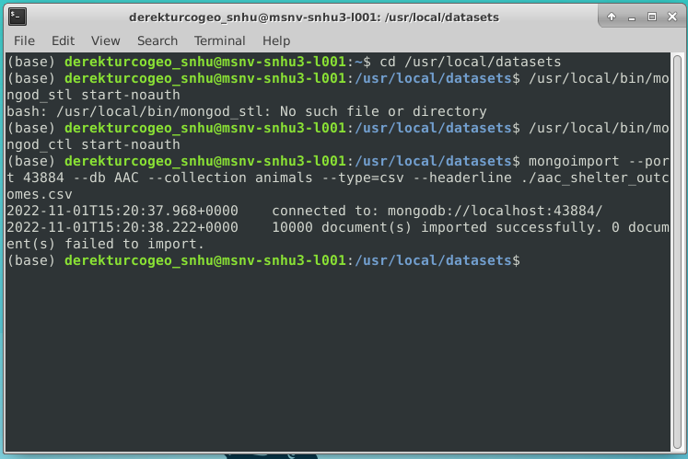

We can then set up user authentication to provide security to our database and data. We will need to set up an administrator account first to manage the database and other user accounts. Then secondly a user account for a user who just needs read and write access to the database as shown below.

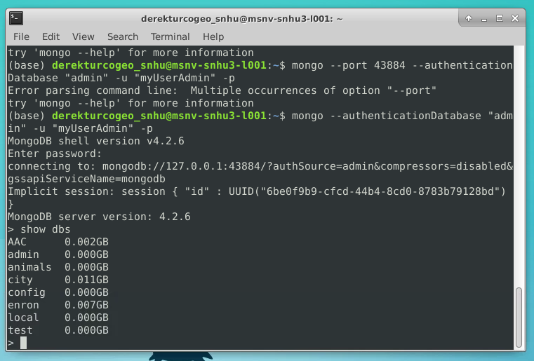

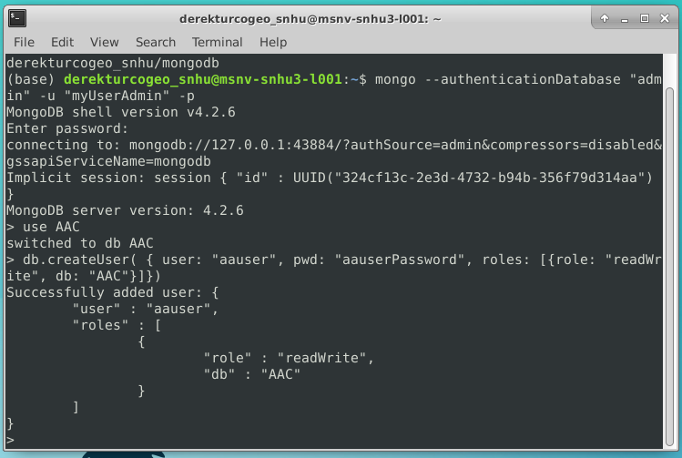

We were then able to index our data to make our database perform faster when searching for specific breeds of dogs. As seen below.

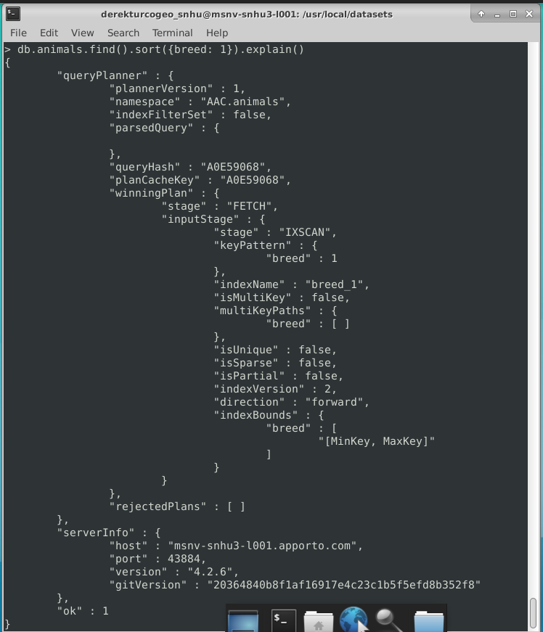

We were then able to develop our CRUD functionality in a Python module. This is the middle layer of our application stack which authenticates users and allows us access to our database outside of the shell program. This layer is basically the glue between our GUI and Database. We first wrote our CRUD.py file and then were able to test its functionality in Jupyter notebook by calling on our functions and making sure they responded properly. Examples of this can be seen in the Usage portion of this README. There were initial challenges connecting to the database through Python, but these turned out to be account problems that caused authentication failures. Once we worked through this authentication problem the database responded and worked as anticipated.

## Installation

The tools needed to build and run our system are MongoDB, Python, and the PyMongo library. The reason we chose these tools is because MongoDB is an easily scalable NoSQL database platform. This means if we need to add new criteria to our database, we do not have to revisit our schema since there isn’t one. For example, if we find a new criterion that makes a dog a good candidate for a specific type of search and rescue work, we can just start adding that new criteria to the database even if it wasn’t tracked previously. This is something not possible with a traditional SQL database without revisiting our schema which would be a lot more work. Python and its PyMongo library are tools that work seamlessly with MongoDB and provide a framework to quickly build our application. Python also has access to many libraries that provide graphical views of data which we will take advantage of in our GUI build.

## Usage

The database or backend of our application has CRUD (Create, Read, Update, Delete) functionality. Below you can see how the Python code we wrote interfaces with the database to create, read, update, and delete documents in our MongoDB. Allowing us to keep the database current and to find and view available animals.

### Code Example

Python CRUD Module:

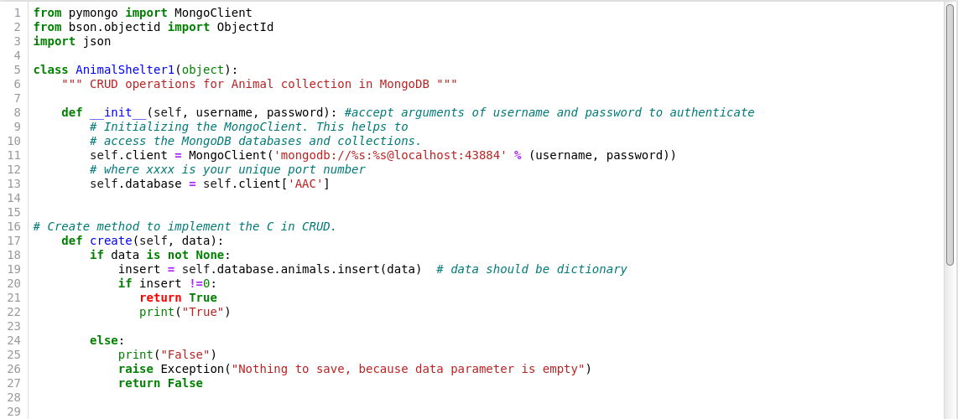

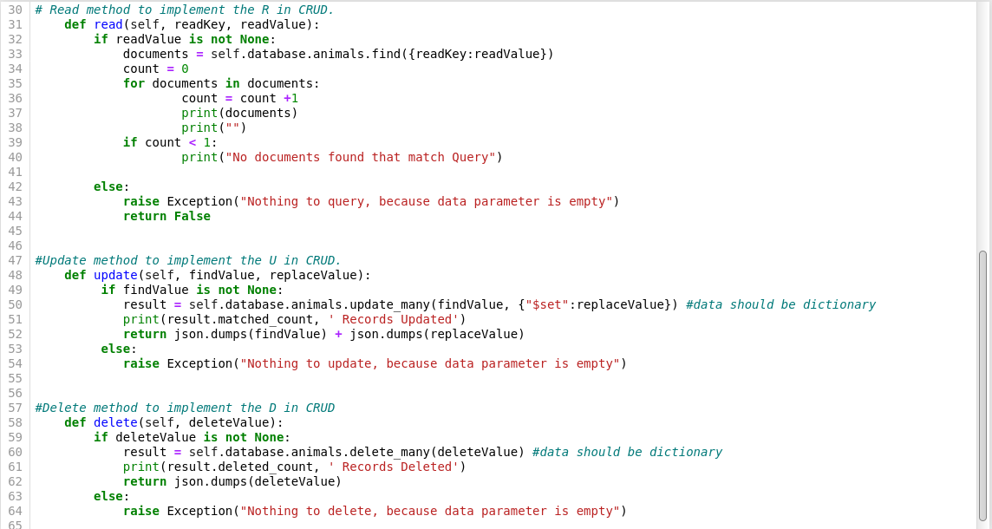

### Tests

We ran multiple tests on our database’s CRUD functionality to determine everything worked as expected. Our test plan was as follows: we added a Burmese Python to our database and then ran a search to read it back. We also queried our database for animal type “dog” to make sure we could return existing data from our compiled database. We then tested the update functionality by updating the color of Burmese Python to Gold and read it back to ensure it was updated. We then Deleted our Python from the database and then tested to ensure it returned a null result. The screen shots below document the full test process.

**Screenshots**

This first example shows how we add a new animal to our database then search for it to confirm it was entered correctly. Testing our Create/Read capability.

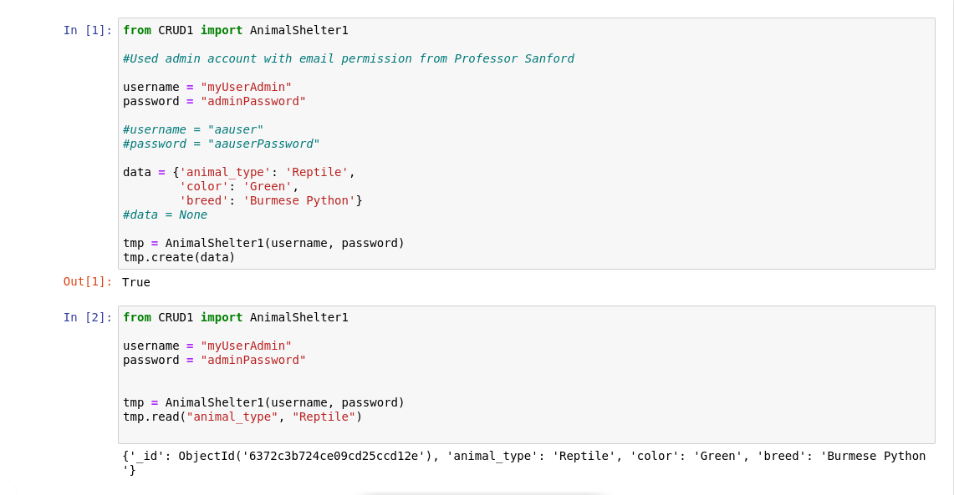

This second screen shot shows how we can query and find all animals of a specific type from our existing data. In this example we returned all animals of the species dogs in our database. This shows that we can find and return pre-existing data in our animals database. Further testing our Read capability.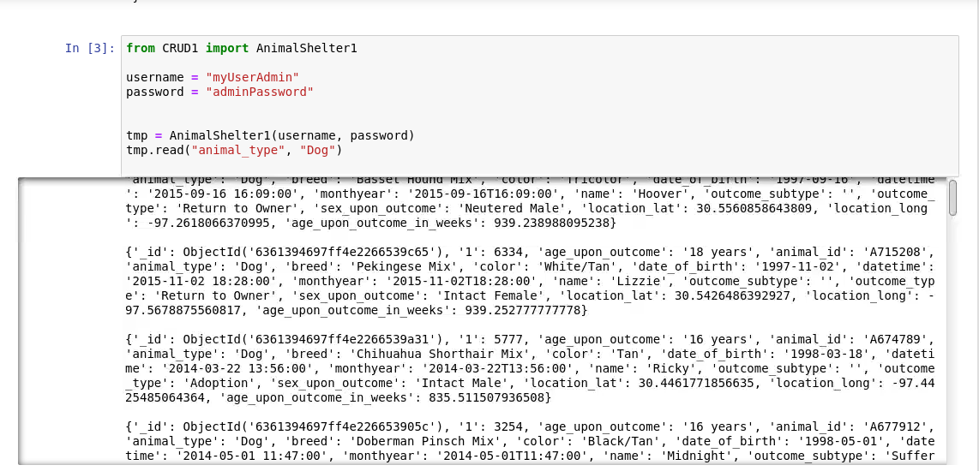

This third screenshot demonstrates our update functionality by updating our Pythons color from Green to Gold. Then we confirm the result with a read test. Testing our Update functionality and Read functionality further.

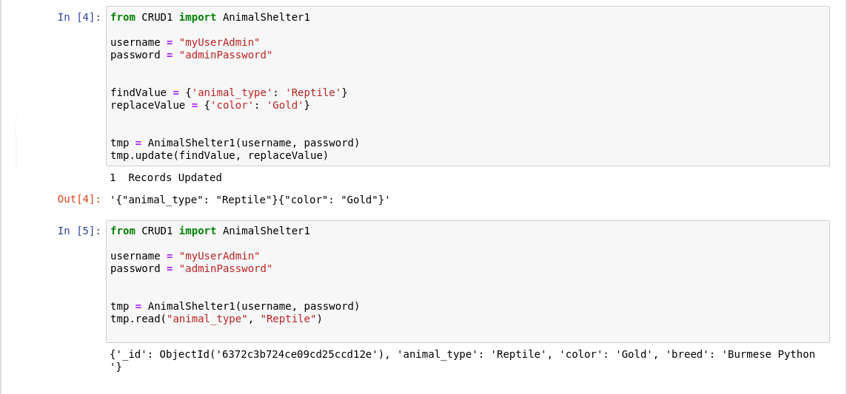

Our Last test demonstrates our delete functionality. We delete Python from our database and then search the database for Python and receive an error message that no results match our query. Demonstrating the document has been removed. Testing our Delete functionality and the Error Handling of our Read functionality when a query returns a null result.

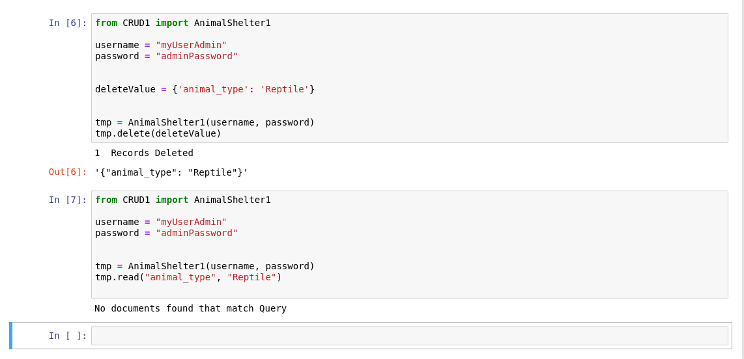

## Web Application and Usage

The final build of our Project contains the Font End and GUI as an html application. The font end by default shows all the animals in our database but has radio button selectors to quickly find animals that meet our criteria for specific rescue work. We have included the customers logo with a hyperlink to the requested website [www.snhu.edu](http://www.snhu.edu) along with our unique name identifying the developer, Derek Turcogeorge. We also implemented sorting and filtering options to our data table to make it easy to navigate a large dataset manually. Below are the screen shots that show the required functionality.

*Below screenshot shows all animals

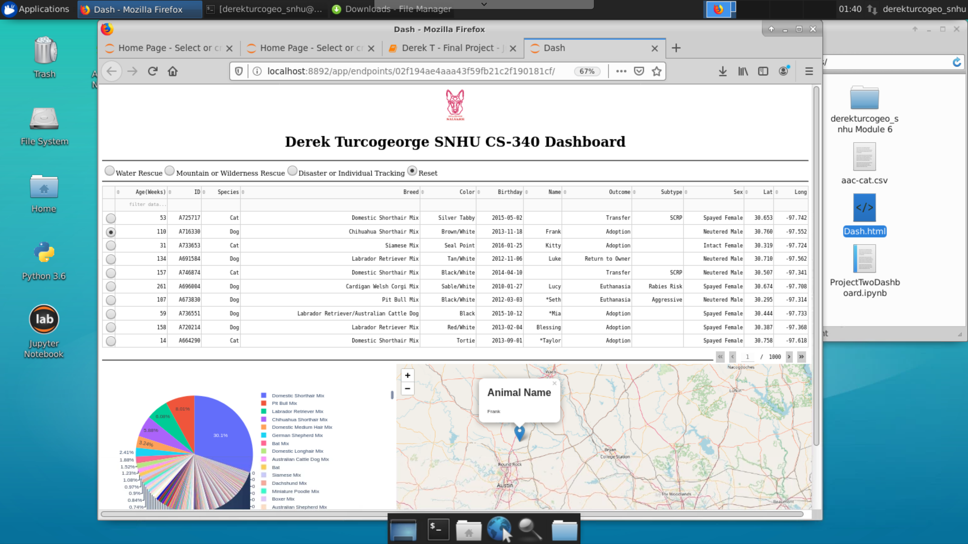

*Below Screenshot shows Mountain and Wilderness Rescue Animal Candidates

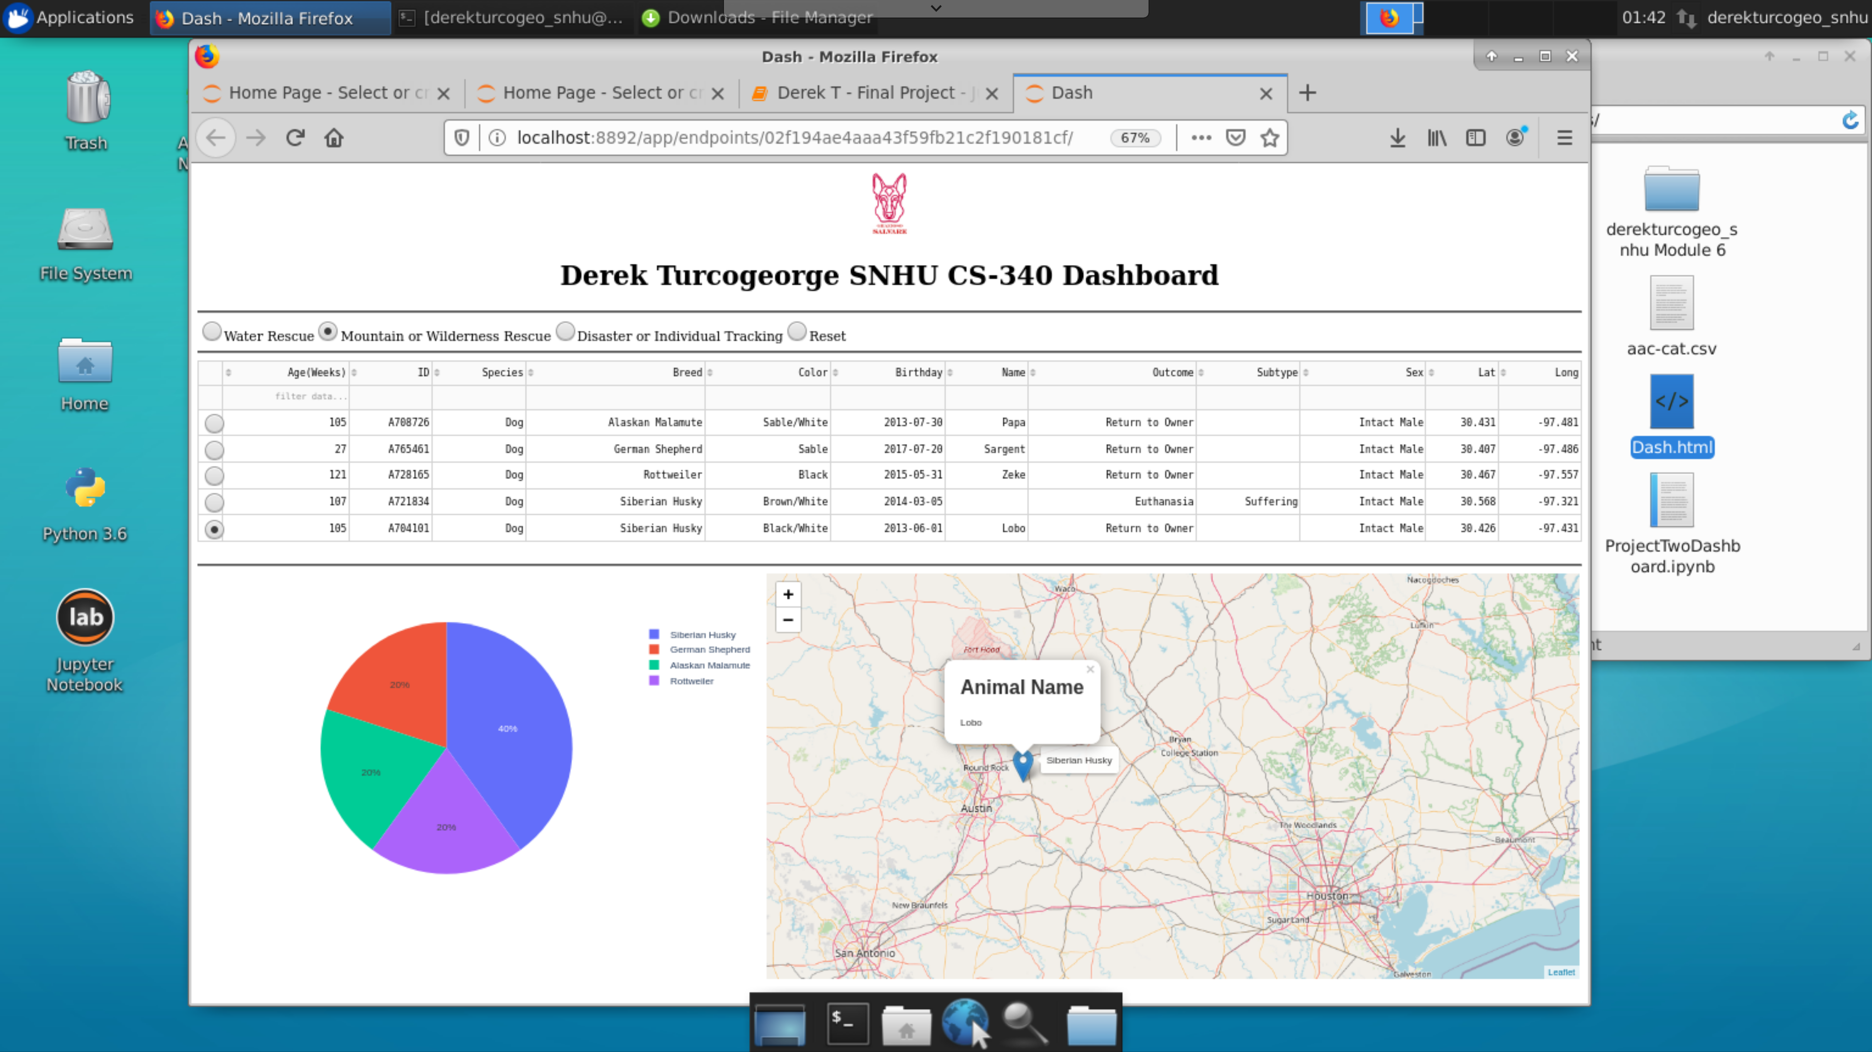

*Below Screenshot shows Water Rescue Animal Candidates

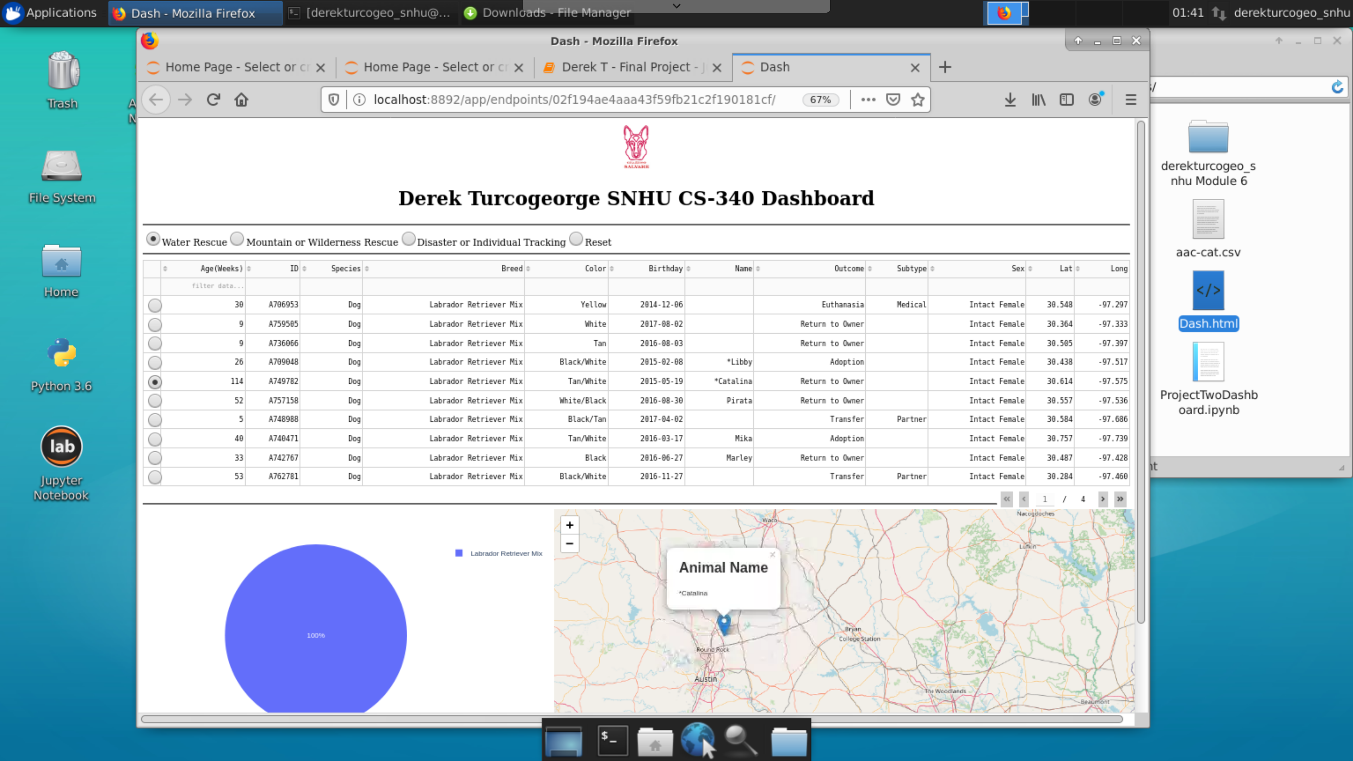

*Below Screenshot shows Disaster or Individual Tracking Rescue Animal Candidates (Virtual Lab was acting up and I was unable to display full dashboard on screen, but I believe this shot shows that it was working fully.)

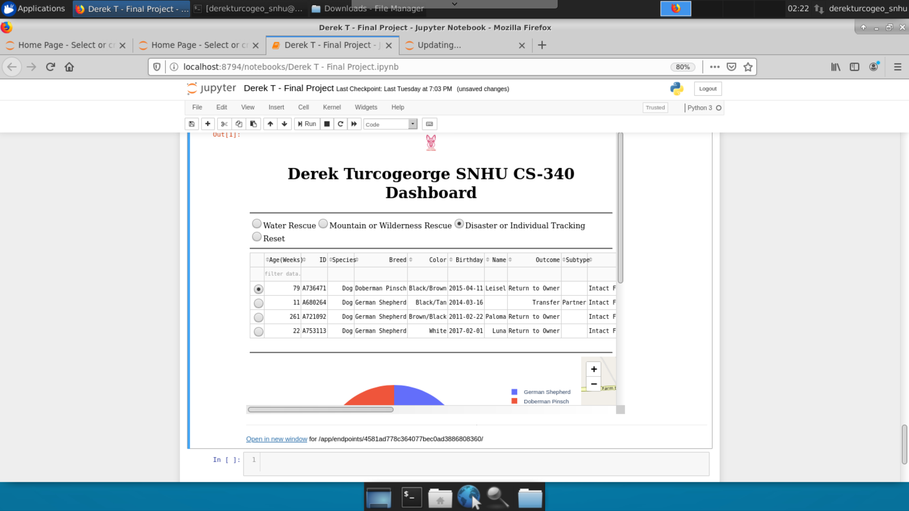

**Tools Used**

The tools used were MongoDB, Python, and the Dash Framework. MongoDB was used because of its utility as a schema less database. This means we can take data from many sources that are not necessarily set up or contain the same information. Something that is not possible with an SQL relational database. This made development and deployment much quicker as we could quickly consolidate data from our five animal shelters and can easily incorporate data from more shelters in the future. Python was a logical choice for our programming language as the PyMongo library makes it quick and easy to interface with the MongoDB with its suite of tools. We lastly used the Dash framework which is a set of tools that are used for data visualization making the queried data from our database easy to understand and visualize.

**Build Process**

The steps taken to build our full stack application were first to install Python and Mongo. Then import all our data from CSV files into a MongoDB. From there we were able to set up security protocols such as user authentication and access. Then we were able to write Python code with reusable functions for CRUD operations on our database. Lastly, we programmed our front end which made use of our CRUD module to import data into our web app which used the dash framework and html to bring the whole application together. The only major hurdle we encountered in development was with loading our data that was returned from our CRUD module into the Dash datable. This was a sticking point for a short time, but we were able to overcome this by speaking with a more experienced dash developer (Professor Sanford). The problem turned out to be a syntax error in the way we were returning data from our CRUD module.

## Contact

Derek Turcogeorge